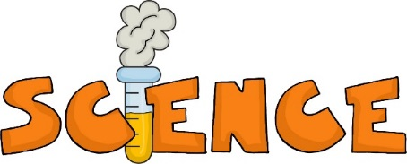

Science Fees for 7th Grade
Science is all about asking questions, making observations, and thinking critically. During this school year, we will be doing various labs to learn more about how the world around us works, and why it happens. In order to see some of these amazing characteristics, we will do some of the following labs, working with soil, candy, cars, minerals, microscopes, and dissections.
- Skittles Frequency
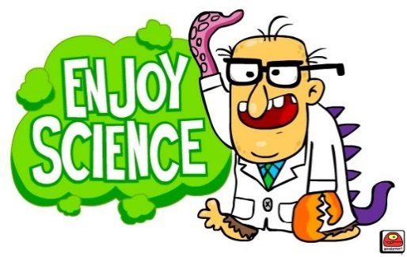
- The Great Gummy Bear Experiment
- Foil Boats
- Mystery Boxes
- Hot Wheels Speed and Acceleration
- Newton’s Law Airplanes
- Cookies and States of Matter
- Rock and Mineral Labs
- Candy Bar Plate Tectonics
- Microscope Labs
- Worm Behavior
- Animal Dissection
In order to do these labs, we require extra funds. The cost of the labs for this year is $4.00. Please send $4.00 cash to your science teacher. She will give you a receipt to show you have paid your lab supply fee. Please have your fee turned in by August 31st.
Looking forward to a great year!

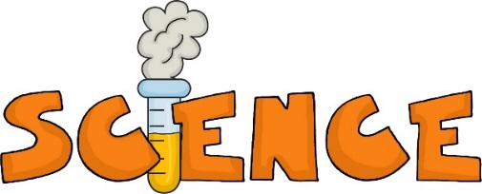

Science Fees for 7th Grade
Science is all about asking questions, making observations, and thinking critically. During this school year, we will be doing various labs to learn more about how the world around us works, and why it happens. In order to see some of these amazing characteristics, we will do some of the following labs, working with soil, candy, cars, minerals, microscopes, and dissections.
- Skittles Frequency
- The Great Gummy Bear Experiment
- Foil Boats
- Mystery Boxes
- Hot Wheels Speed and Acceleration
- Newton’s Law Airplanes
- Cookies and States of Matter
- Rock and Mineral Labs
- Candy Bar Plate Tectonics
- Microscope Labs
- Worm Behavior
- Animal Dissection
In order to do these labs, we require extra funds. The cost of the labs for this year is $4.00. Please send $4.00 cash to your science teacher. She will give you a receipt to show you have paid your lab supply fee. Please have your fee turned in by August 31st.
Looking forward to a great year!

